Design an HTML page with the relevant CSS (inline /internal/external styles)for the following use case:
e. WhatsApp Web login page, as depicted in the figure

SOURCE CODE

<!DOCTYPE html>
<html>
<head>
<title>WhatsApp Web Login</title>

<style>
body {
background-color: #f0f2f5;
font-family: Arial, sans-serif;
margin: 0;
padding: 30px;
color: #333333;
}

.container {
background-color: white;
margin-top: 50px;
width: 85%;
margin: auto;
padding: 40px;
}

.login-section {
display: flex;
justify-content: space-around;
align-items: center;
padding: 25px;
}

.instructions {
width: 55%;
line-height: 1.5;
}

.instructions h2 {
color: #222222;
font-size: 26px;
margin-bottom: 25px;
}

.step {
display: flex;
align-items: center;
gap: 12px;
margin-bottom: 15px;
}

.number {
border: 1px solid #777777;
border-radius: 50%;
width: 26px;
height: 26px;
display: flex;
justify-content: center;
align-items: center;
flex-shrink: 0;
font-size: 14px;
}

.step p {
margin: 0;
}

.qr-section {
width: 40%;
text-align: center;
}

.qr-code img {
width: 220px;
height: 220px;
}

.phone-login {
text-align: right;
color: #128c7e;
margin-top: 35px;
font-weight: bold;
}

.phone-login a {
color: #128c7e;
text-decoration: none;
}

.phone-login a:hover {
color: #075e54;
}
</style>
</head>

<body>
<div class="container">
<div class="login-section">
<div class="instructions">
<h2>Log in to WhatsApp</h2>

<div class="step">
<span class="number">1</span>
<p>Open <b>WhatsApp</b> on your phone.</p>
</div>

<div class="step">
<span class="number">2</span>
<p>On Android tap <b>Menu</b>. On iPhone tap <b>Settings</b>.</p>
</div>

<div class="step">
<span class="number">3</span>
<p>Tap <b>Linked devices</b>, then <b>Link device</b>.</p>
</div>

<div class="step">
<span class="number">4</span>
<p>Scan the QR code to confirm.</p>
</div>
</div>

<div class="qr-section">
<div class="qr-code">
<img src="qr-code.png" alt="WhatsApp QR Code" />
</div>

<div class="phone-login">
<a href="#">Log in with phone number &#8250;</a>
</div>
</div>
</div>
</div>
</body>
</html>

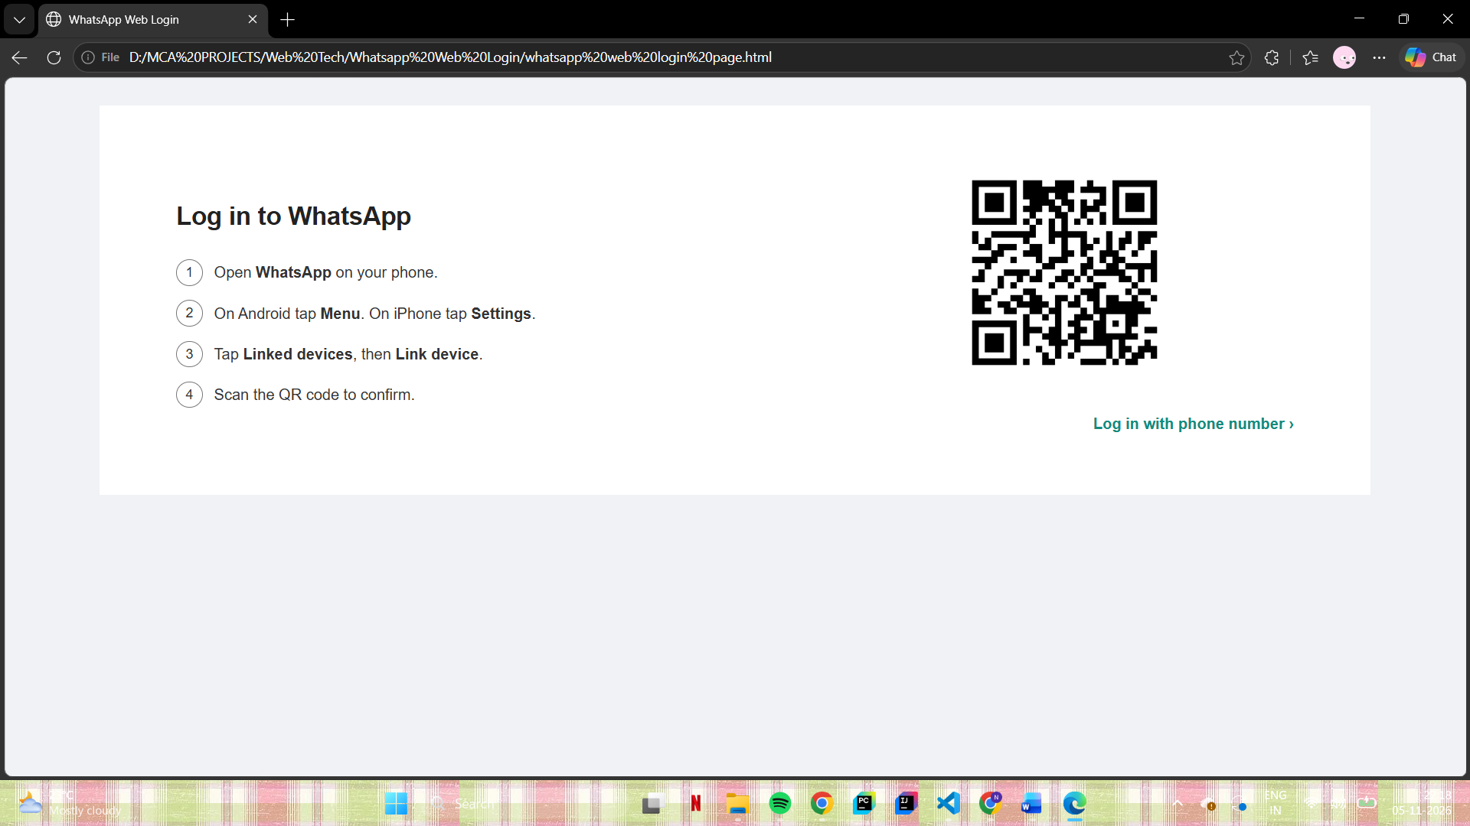
OUTPUT

